To execute the running java class

1. Install posgress daabase(make note of data base username:postgres password: the one you provided during install)
2. Open PgAdmin
3. Once you inside pgadmin right click on database->create database->call it (COS301)

Your structure should be

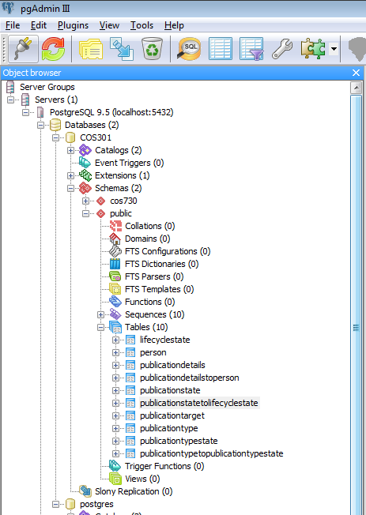

Please not under schema public. The tables created automatically, I did not create those tables. I believe is because of the persistence.xml file in netbeans

Make sure you change the persistence.xml as follows

|  |
| --- |
| <?xml version="1.0" encoding="UTF-8"?>  <persistence version="2.1" xmlns="http://xmlns.jcp.org/xml/ns/persistence" xmlns:xsi="http://www.w3.org/2001/XMLSchema-instance" xsi:schemaLocation="http://xmlns.jcp.org/xml/ns/persistence http://xmlns.jcp.org/xml/ns/persistence/persistence_2_1.xsd">  <persistence-unit name="cos301PU" transaction-type="RESOURCE_LOCAL">  <provider>org.eclipse.persistence.jpa.PersistenceProvider</provider>  <class>Entities.Person</class>  <class>Entities.Publicationtarget</class>  <class>Entities.Publicationtypestate</class>  <class>Entities.Publicationtype</class>  <class>Entities.Publicationdetails</class>  <class>Entities.Publicationstate</class>  <class>Entities.Lifecyclestate</class>  <class>Entities.Publicationdetailstoperson</class>  <class>Entities.Publicationstatetolifecyclestate</class>  <class>Entities.Publicationtypetopublicationtypestate</class>  <properties>  <property name="javax.persistence.jdbc.url" value="jdbc:postgresql://localhost:5432/COS301"/>  <property name="javax.persistence.jdbc.user" value="postgres"/>  <property name="javax.persistence.jdbc.driver" value="org.postgresql.Driver"/>  <property name="javax.persistence.jdbc.password" value="APC9dfTA"/>  </properties>  </persistence-unit>  </persistence> |

Now create connection to database in netbeans

Services->database->new connection

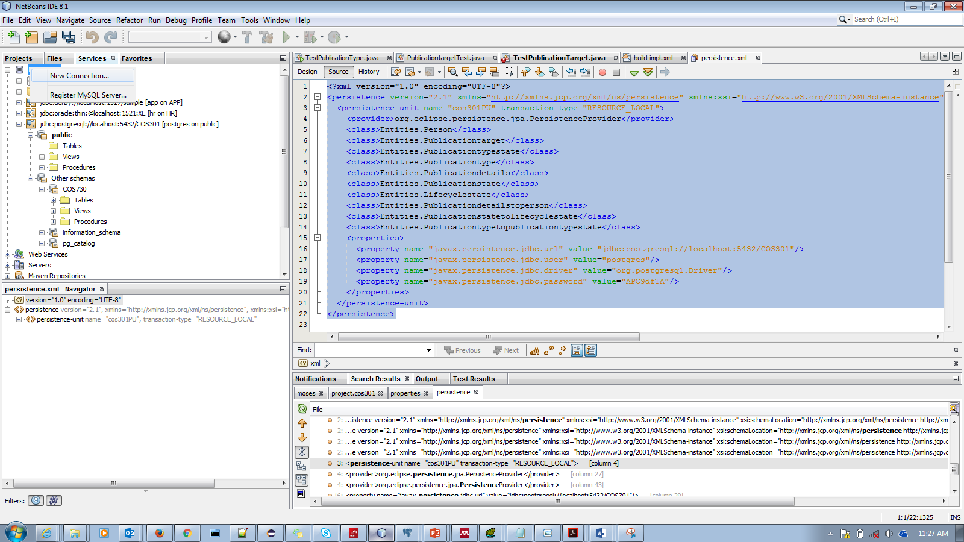

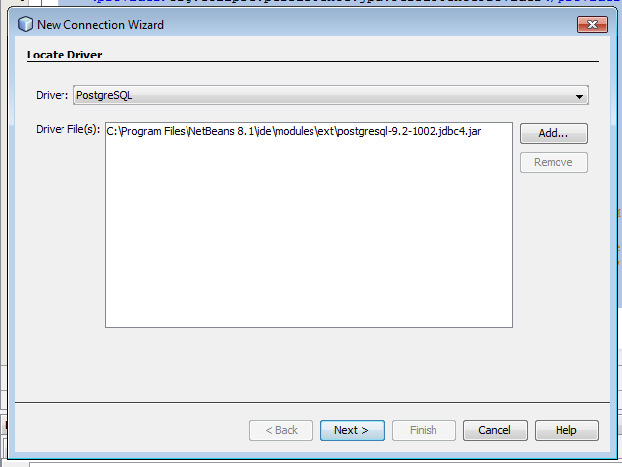

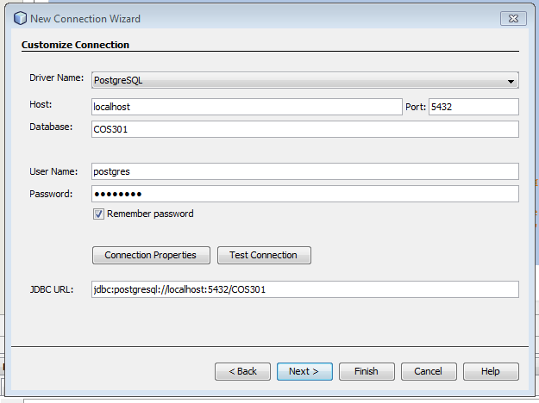

Make note of the JDBC URL, it must be the same as the one in **persistence.xml**

|  |
| --- |
| <?xml version="1.0" encoding="UTF-8"?>  <persistence version="2.1" xmlns="http://xmlns.jcp.org/xml/ns/persistence" xmlns:xsi="http://www.w3.org/2001/XMLSchema-instance" xsi:schemaLocation="http://xmlns.jcp.org/xml/ns/persistence http://xmlns.jcp.org/xml/ns/persistence/persistence_2_1.xsd">  <persistence-unit name="cos301PU" transaction-type="RESOURCE_LOCAL">  <provider>org.eclipse.persistence.jpa.PersistenceProvider</provider>  <class>Entities.Person</class>  <class>Entities.Publicationtarget</class>  <class>Entities.Publicationtypestate</class>  <class>Entities.Publicationtype</class>  <class>Entities.Publicationdetails</class>  <class>Entities.Publicationstate</class>  <class>Entities.Lifecyclestate</class>  <class>Entities.Publicationdetailstoperson</class>  <class>Entities.Publicationstatetolifecyclestate</class>  <class>Entities.Publicationtypetopublicationtypestate</class>  <properties>  <property name="javax.persistence.jdbc.url" value="jdbc:postgresql://localhost:5432/COS301"/>  <property name="javax.persistence.jdbc.user" value="postgres"/>  <property name="javax.persistence.jdbc.driver" value="org.postgresql.Driver"/>  <property name="javax.persistence.jdbc.password" value="APC9dfTA"/>  </properties>  </persistence-unit>  </persistence> |

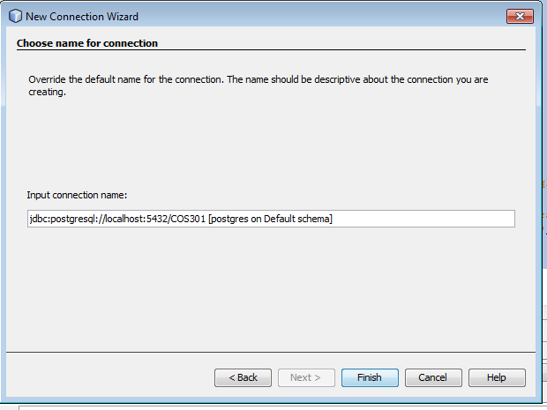



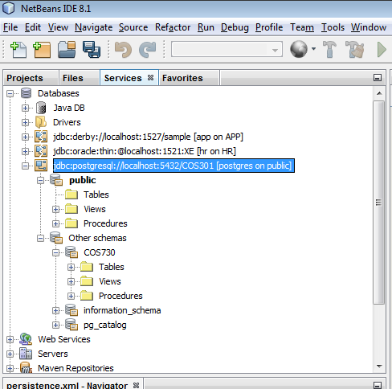

NOW MAKE SURE THE TABLES HAVE SOME DATA

If there is no data in the tables, the application throws arrayout bounds errors

Go back to Postgres PgAdmin

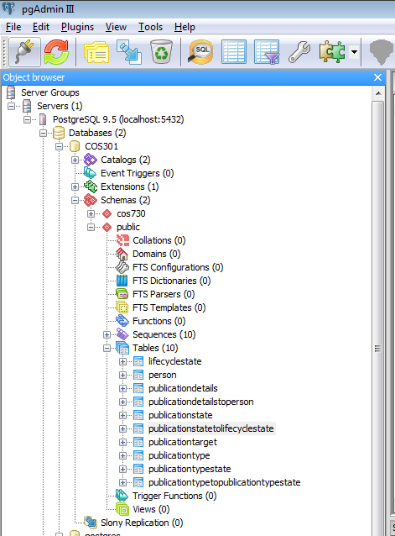

Then run the below SQL commands to insert records

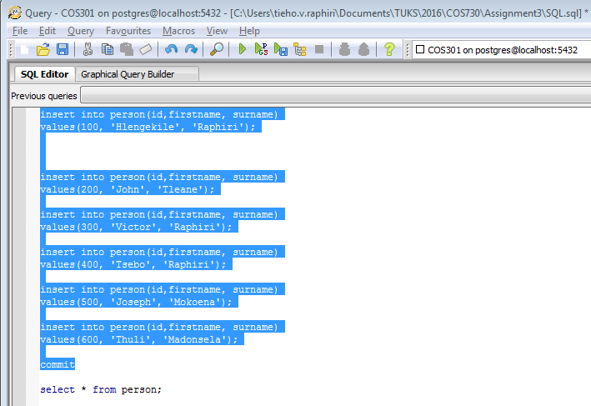

**Make sure all inserts on SQL are run to create sample data**

|  |
| --- |
| insert into person(id,firstname, surname)  values(100, 'Hlengekile', 'Raphiri');  insert into person(id,firstname, surname)  values(200, 'John', 'Tleane');  insert into person(id,firstname, surname)  values(300, 'Victor', 'Raphiri');  insert into person(id,firstname, surname)  values(400, 'Tsebo', 'Raphiri');  insert into person(id,firstname, surname)  values(500, 'Joseph', 'Mokoena');  insert into person(id,firstname, surname)  values(600, 'Thuli', 'Madonsela');  commit  select * from person;  insert into lifecyclestate(id,bibtexentry, percentagecompleted, publicationdate, state)  values(100, 'Authentication on the cloud1', 90, '03/01/16', 'Published');  insert into lifecyclestate(id,bibtexentry, percentagecompleted, publicationdate, state)  values(200, 'Authentication on the cloud2', 90, '03/02/16', 'Rejected');  insert into lifecyclestate(id,bibtexentry, percentagecompleted, publicationdate, state)  values(300, 'Authentication on the cloud3', 90, '03/03/16', 'Submitted');  insert into lifecyclestate(id,bibtexentry, percentagecompleted, publicationdate, state)  values(500, 'Authentication on the cloud2', 90, '03/05/16', 'In Progres');  insert into lifecyclestate(id,bibtexentry, percentagecompleted, publicationdate, state)  values(600, 'Authentication on the cloud5', 90, '03/06/16', 'In Progres');  select * from lifecyclestate;  insert into publicationtarget(id,name, website)  values(100, 'IEEEE','www.ieee.com');  insert into publicationtarget(id,name, website)  values(200, 'CAM','www.cam.com');  insert into publicationtarget(id,name, website)  values(300, 'springer','www.springer.com');  insert into publicationtarget(id,name, website)  values(400, 'liever','www.liever.com');  insert into publicationtarget(id,name, website)  values(500, 'mcmillin','www.mcmillin.com');  insert into publicationtarget(id,name, website)  values(600, 'mcmillin','Google');  select * from publicationtarget;  insert into publicationtype(id,name)  values(2, 'VIC_PAPERS');  insert into publicationtype(id,name)  values(100, 'Journal');  insert into publicationtype(id,name)  values(200, 'Book');  insert into publicationtype(id,name)  values(300, 'Conference');  insert into publicationtype(id,name)  values(500, 'Google');  commit  select * from publicationtype; |

If there is no data in the database, you will get the array out of bound error

I then open TestPerson.java

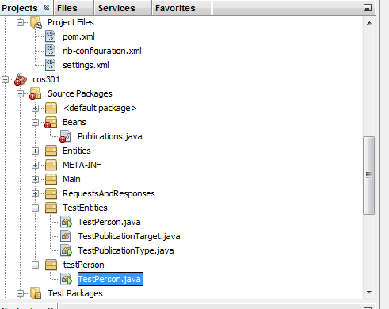

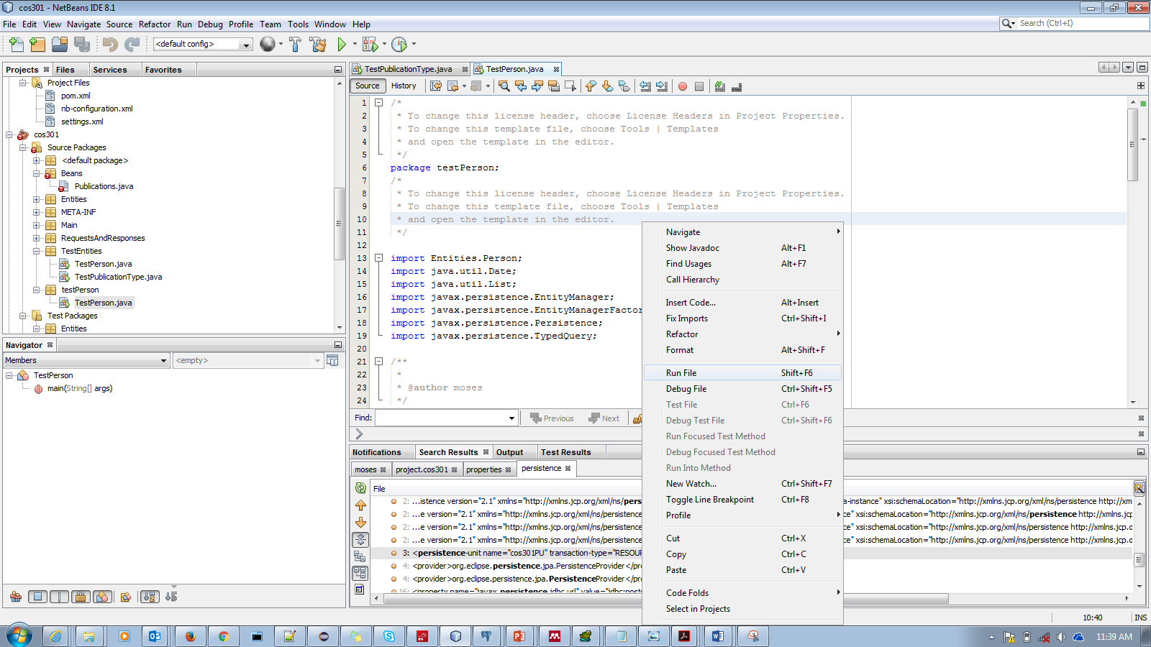

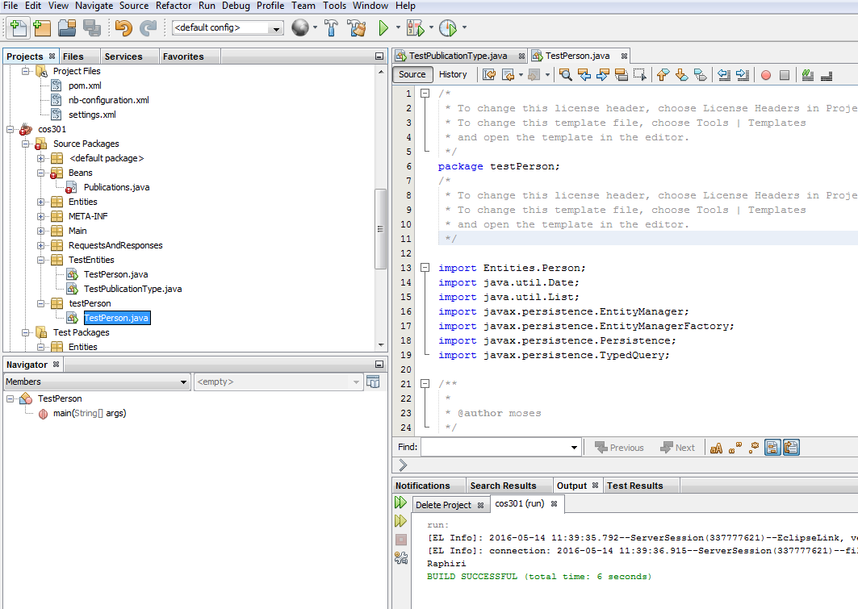

I then open Publicationtype.java

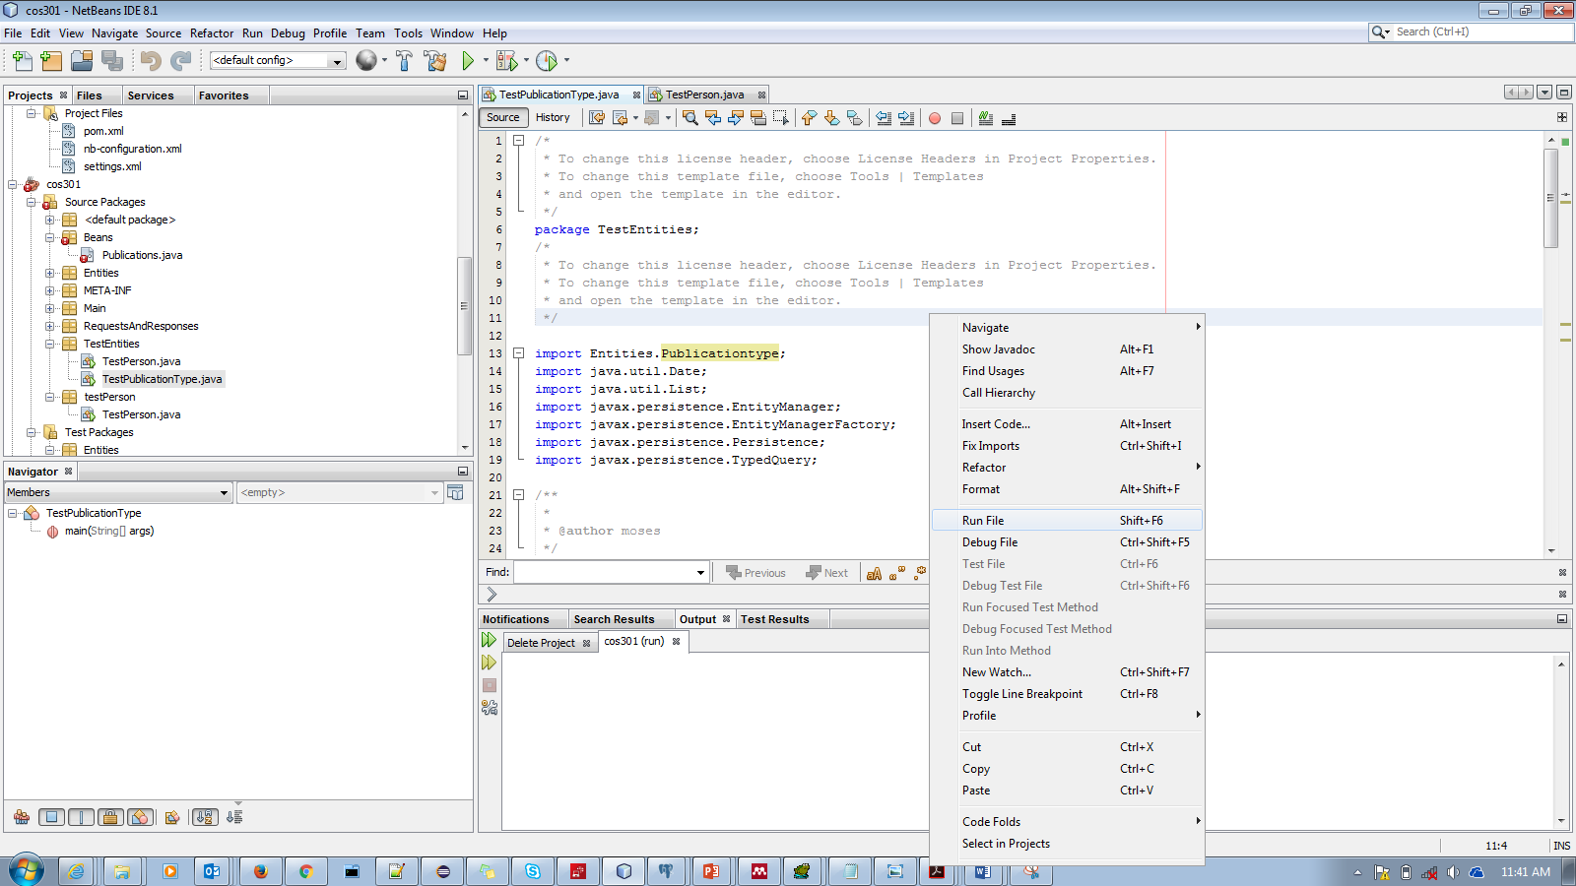

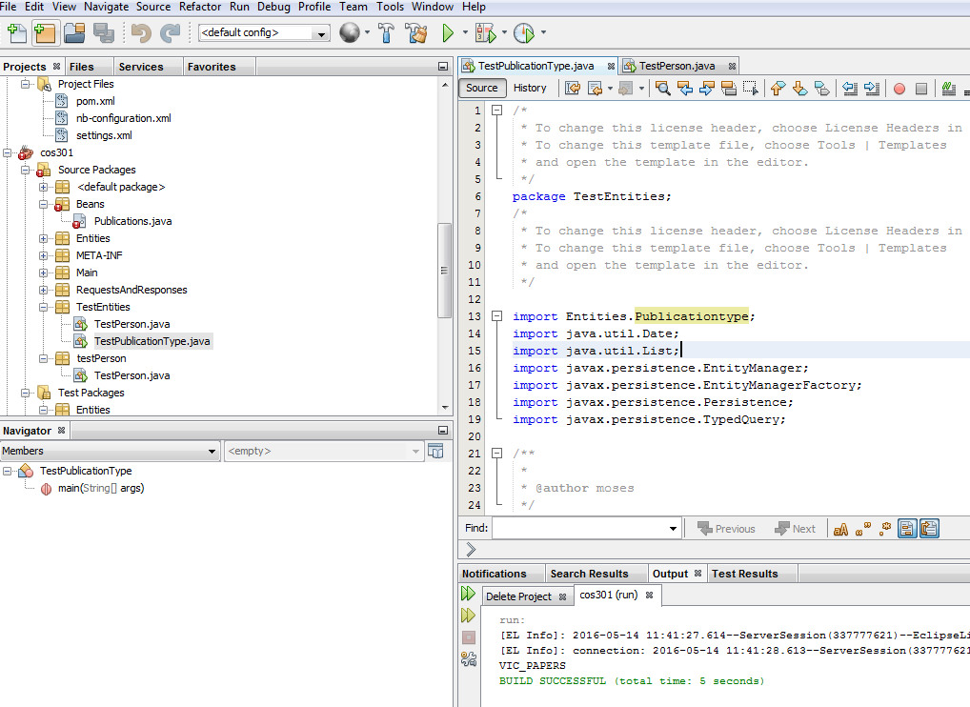

Comment out @Remote inside Publications.java

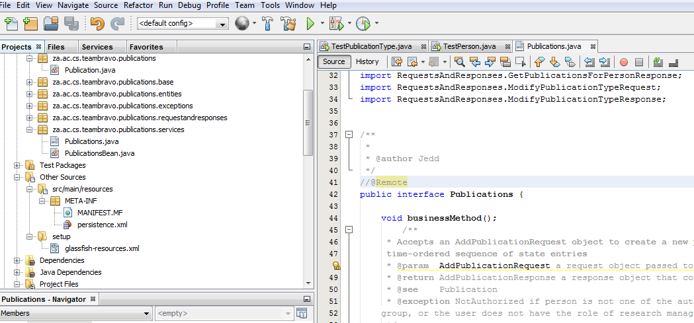

To connect to any application server(jboss, oracle weblogic etc)

Open netbeans

Servers->add server

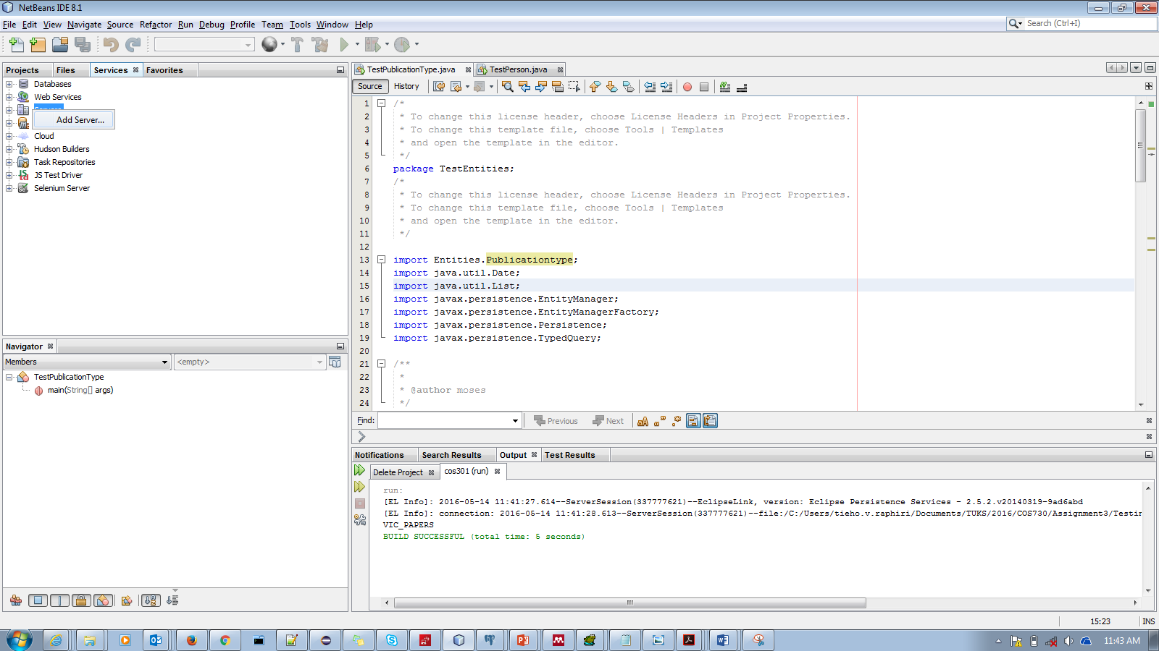

I chose weblogic since I am competent in weblogic but I did the same thing with jboss. The steps are straight forward

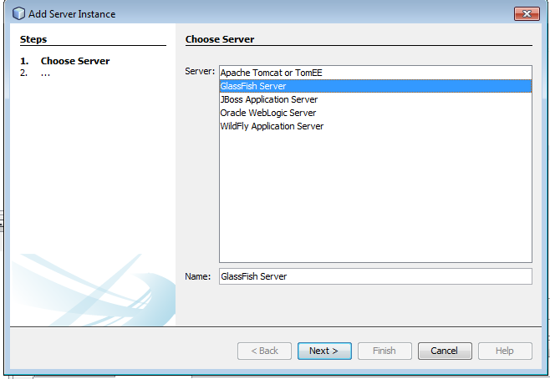

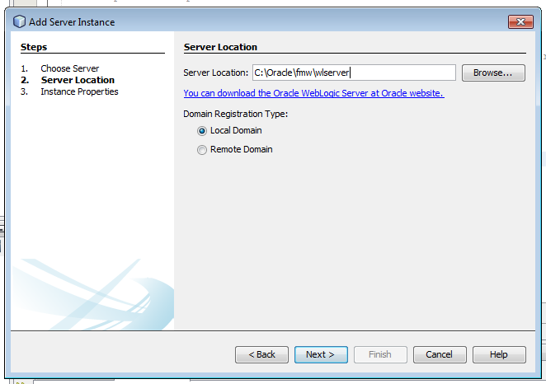

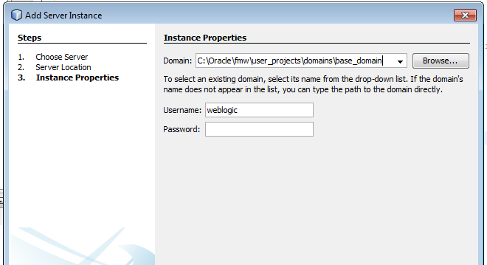

Enter username and password and domain. Leave the rest as defaults

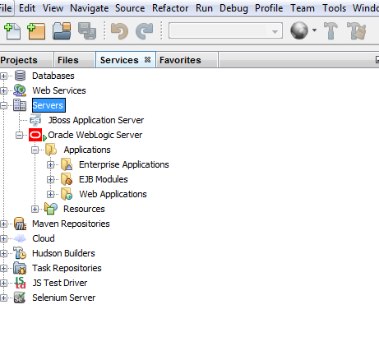

OTHER SURPRISE ISSUE FOR ME REGARDING ERRORS

If you look carefully on netbeans inside PublicationBean.java I get below error

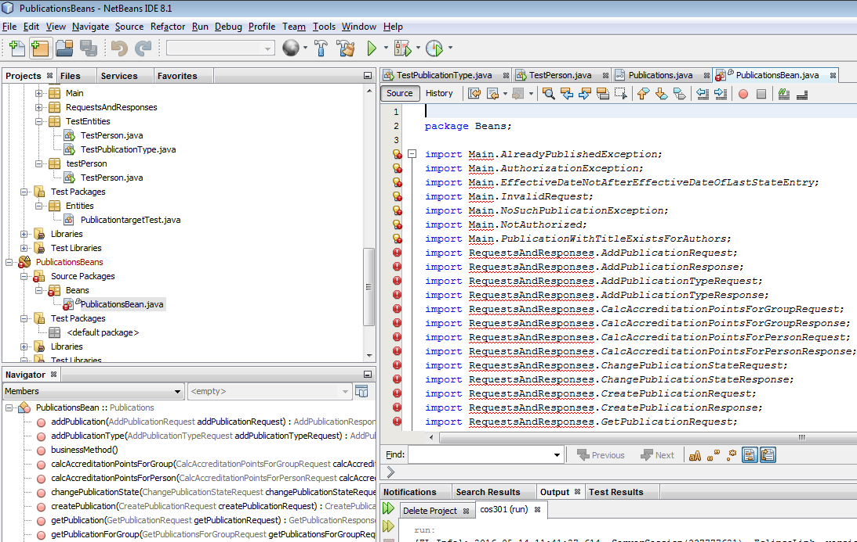

But when I open the same class in eclipse mars, I don’t get those errors. I think is library issue

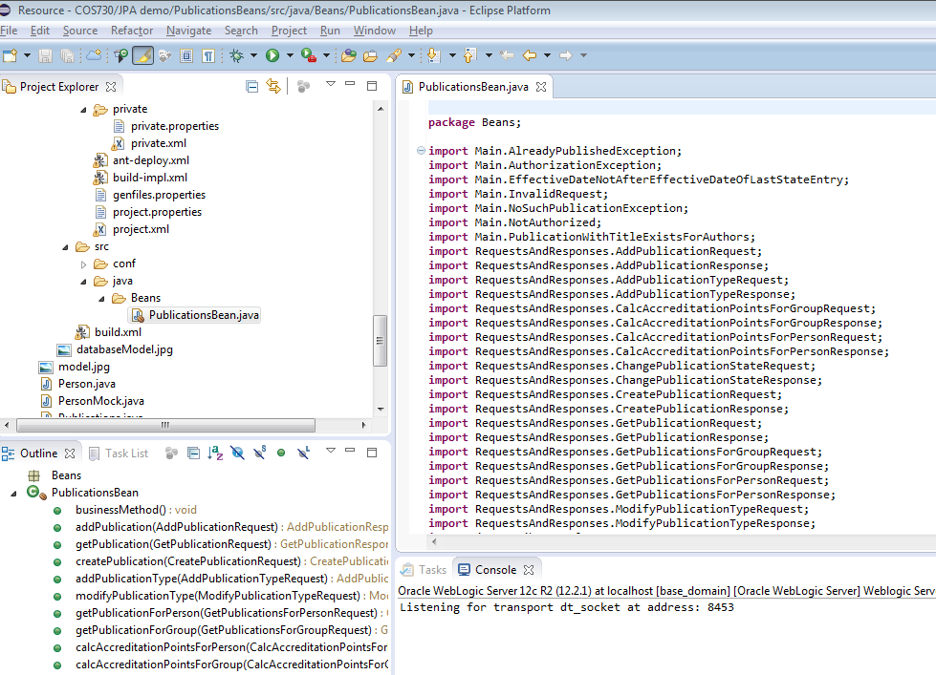

No errors at all on eclipse. I just don’t know how to run these classes in eclipse

I created all connection to db, app server in eclipse. Strange enough no errors at all in eclipse. I am not sure how to do the unit test etc in eclipse

